Case 2-A167a-ME-Assyria-Ashur-Foundation Nail-terracotta-2100 BCE

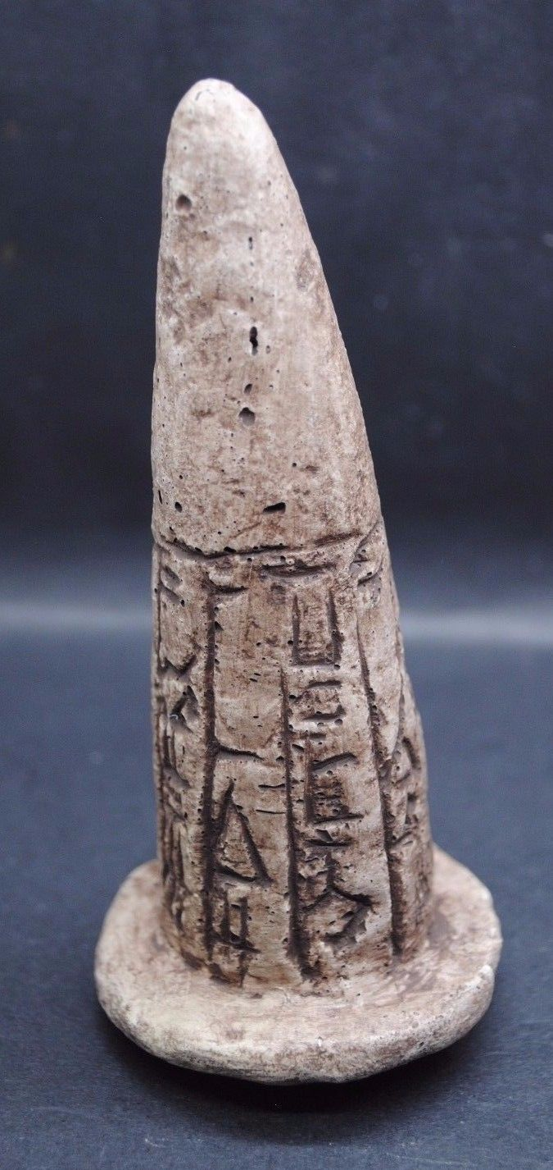 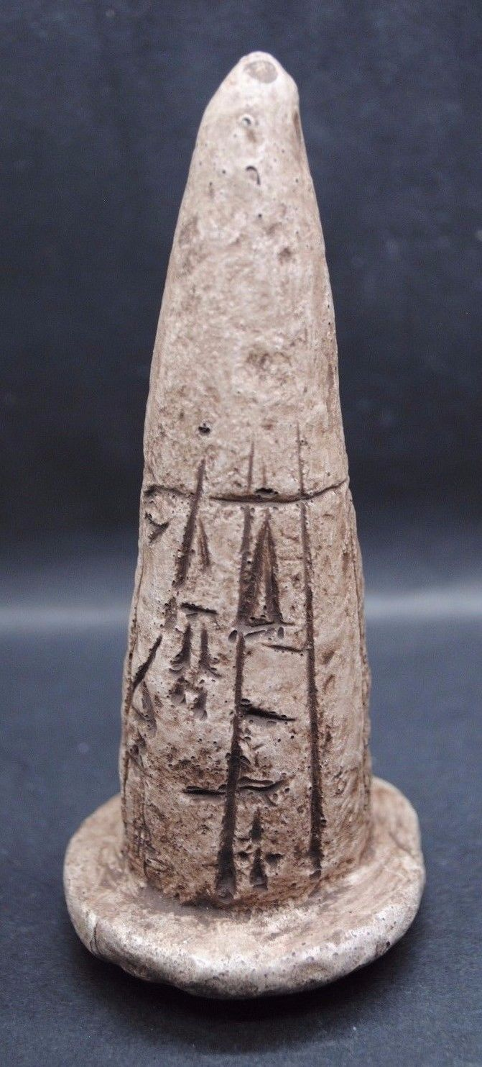

**Case no.: 2**

**Accession Number: A167**

**Formal Label:** ME-Mesopotamia-Foundation Cone

**Display Description:**

**Foundation terracotta** cones or nails were inscribed with cuneiform, fired in a kiln and implanted into the med-brick wall of a temple or building to record that it was the divine property of the deity to whom it was dedicated. Ashur is located on the Tigris River in northern Mesopotamia in a specific geo-ecological zone, at the borderline between rain-fed and irrigation agriculture. The city dates back to the 3rd millennium BC.

**LC Classification: PJ3721.A69**

**Date or Time Horizon:** 2100 BCE

**Geographical Area:** Ashur, Assyria

**Map:**

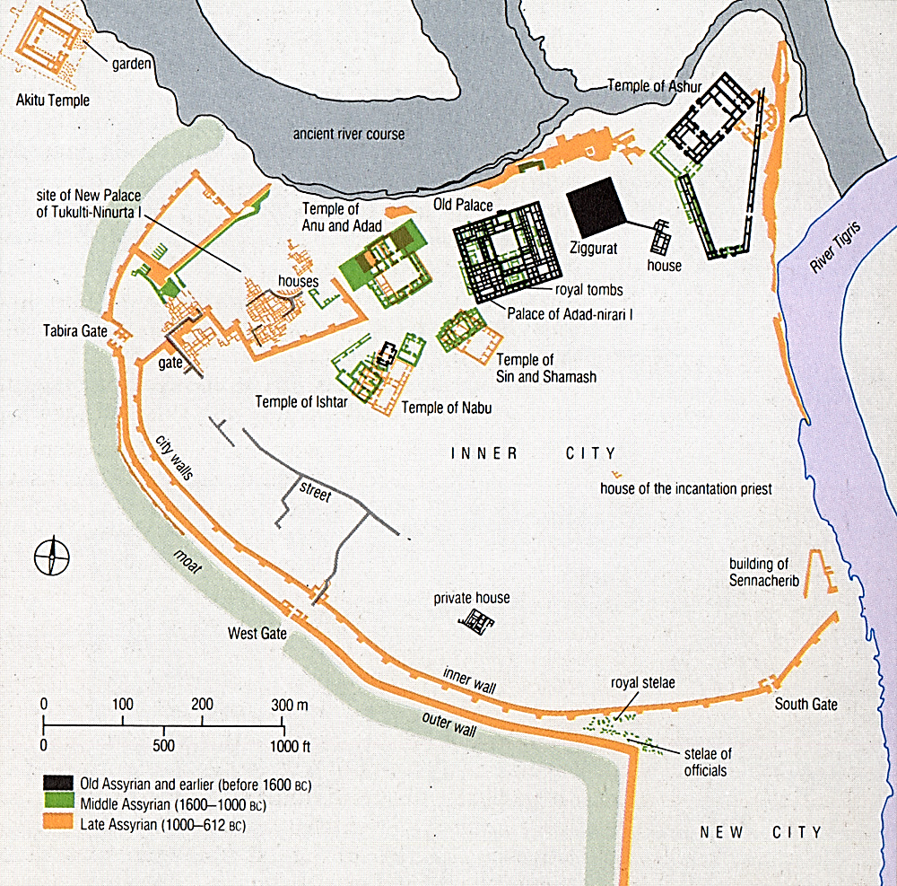

Ashur site plan   Courtesy [www.bet-davvid.com](http://www.bet-davvid.com/Heritage.html)

http://www.thelivingmoon.com/43ancients/04images/Assyrians/AshurSitePlan.jpg

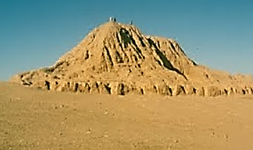

**Temple of Ashur. After** [**http://3.bp.blogspot.com**](http://3.bp.blogspot.com)

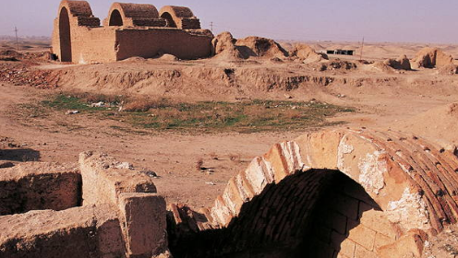

**GPS coordinates:** [35°27′24″N 43°15′45″E](https://tools.wmflabs.org/geohack/geohack.php?pagename=Assur&params=35_27_24_N_43_15_45_E_type:landmark)

**Cultural Affiliation:**

**Medium:** original, fired clay; replica, resin

**Dimensions:** H 139.20 mm 5.480 in; dia 61,33 2.414 in

**Weight: n/a**

**Condition: replica**

**Provenance:** museum replica

**Discussion:**

Ashur was dedicated to the god Ashur and its temple was the center of his worship. It also was famous for its double temple of Anu and Adad and the temple of Ishtar, the Sumerian goddess of love and war. It was also the city-state capital of the Assyrian Empire that was active in international trade and exchange from the 14th to the 9th centuries BCE. Sun-dried mud-bricks were set on foundations of quarried, dressed stone for the buildings. The city was surrounded by a double wall with several gates and a big moat. Ashur had two zones: an old city in the north (Akkadian, *libbi-ali,* the heart of the city), and a newer city (ca mid-2nd millennium BCE) in the south.

**References:** Donbaz, Veysel. *Royal inscriptions on clay cones from Ashur now in Istanbul*. Toronto; Buffalo: University of Toronto Press

|  |  |
| --- | --- |
|  | Link |